Lauren West

Math 189Z

17 April 2020

Worked with Evan Coulson

**Deliverables**

**Task 1:**

my_stops = text.ENGLISH_STOP_WORDS.union(

['covid', 'got', 'ly','covid_19','COVID', '19', 'covid19', '000', 'don', 'doesn','2020', 'am','virus', 'www','amp', 'http', 'corona', 'coronavirus', 'said', 'stated', 'described', 'novel', 'really', 'very', 'https', 'com', 'despite', 'to', 'single', 'first', 'group', 'similar', 'different', 'like', 'alike']

)

**Tasks 2 and 3**:

This graph shows us that the topics in the tweets are fair bit structured, with them being concentrated around a series of topics. This means that there is interrelatedness in the tweets that manifests in close proximity. For example, this graph shows us that topic 7 would be much more related to topic 3 than it would be to topic 6.

**Task 4:** Image of ‘Monthly Tweet Counts by Topic’ bar graph

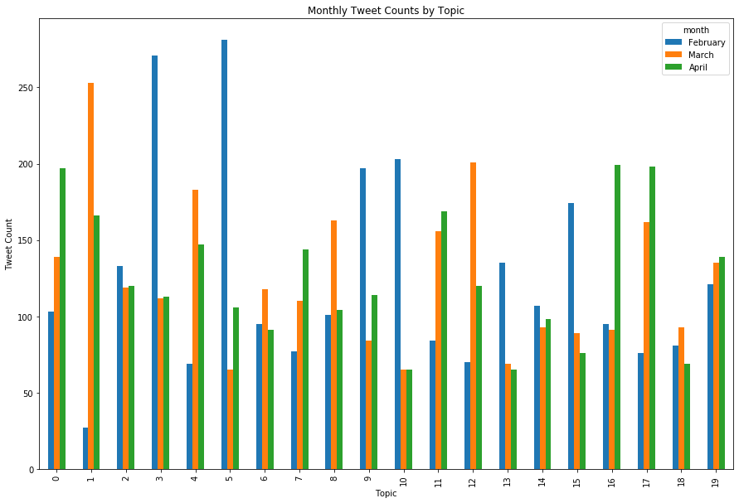

**Task 5**: Discussion of results (what you need to discuss is explained in Jupyter Notebook):

**February: Topic 5**

['china', 'chinese', 'outbreak', 'global',

'apple', 'masks', 'pandemic', 'countries',

'demand', 'crisis', 'amid', 'production']

**Semantic meaning**: Early spread from China rises to global threat.

**March : Topic 1**

['says', 'white', 'positive', 'trump',

'negative', 'breaking', 'realdonaldtrump',

'house', 'tested', 'tests', 'test', 'president']

**Semantic meaning**: COVID-19 in America, testing ramps up and Trump

is forced to address the spread.

**April: Topic 16**

['china', 'fight', 'world', 'outbreak', 'human', 'going',

'gone', 'cure', 'home', 'person', 'let', 'love']

**Semantic Meaning:** The world is pushing back and fighting.

for solutions.

**Present in all four months with similar Tweet Count**: **Topic 2**

['people', 'chinese', 'vaccine', 'uk', 'government',

'research', 'say', 'crisis', 'scientists', 'way', 'right', 'fact']

**Semantic Meaning:**

The situation is a crisis throughout, scientists and governments

searching for facts and the right way to proceed.

**Qualitative Analysis of Topic Modeling:**

The results of these bar graphs make sense after assigning semantic meaning! We see in February popular twitter discussion concentrates on the issue in “China”, and how it was evolving to become an issue of “global” scale, a “pandemic”. In March, coronavirus in the United States gets a foothold, and “Trump” moves to respond to the virus and ramp up “testing” to get “positive” ad “negative” results. In April, we see the fight continue as people hope for a “cure”, and “human” interaction occurs virtually to spread the “love” during the “outbreak”. All four months, we see the consistent search for the “right” “way” to address these issues by “government” and we seek “fact” from “research” done by “scientists”. The results of the bar graph definitely make sense, seeing that it encapsulates the tone of the populous on twitter regarding coronavirus, and how public opinion has evolved over time.